Name: Bontle Lindiwe

Surname: Maloka

Student Number: ST10487239

Module: WEDE5020- Web Development (Introduction)

Portfolio of Evidence (POE) Part1
Website Proposals

Submission Date: 14 August 2026

Table of Contents: Proposal 1: Sweet Crumbs Bakery

Contents | Page
1. Organization Overview | 3
2.Website Goals and Objectives | 4
3. Current Websites Analysis | 5
4.Proposed Website Features and Functionality | 5
5. Design and User Experience | 5
5.1 Low Fidelity Wireframes | 6
6. Technical Requirements | 7
7. Timeline and Milestones | 7
8. Budget | 7
10 REFERENCES | 7

PROPOSAL 1: SWEET CRUMBS BAKERY

1. Organisation Overview

Organisation Name:
Sweet Crumbs Bakery (Pty) Ltd

Background:
Sweet Crumbs Bakery is a fictional small business located in Johannesburg, South Africa. Established in 2022, the bakery specialises in freshly baked bread, cakes, cupcakes, pastries, cookies and customised cakes for birthdays, weddings and other celebrations. The bakery currently relies on walk-in customers, social media and WhatsApp for marketing and customer communication. However, without a dedicated website, customers cannot easily browse products or submit online enquiries.

Mission
To provide fresh, high-quality baked goods made with premium ingredients while delivering excellent customer service that exceeds customer expectations.

Vision
To become Johannesburg’s leading neighbourhood bakery by expanding its digital presence, improving customer convenience and building long-term relationships through quality products and exceptional service.

Target Audience
The website will target:
- Families purchasing cakes and baked goods.
- Students looking for affordable snacks.
- Working professionals buying breakfast and lunch items.
- Event planners organising weddings and birthdays.
- Local businesses requiring catering services.

2. Website Goals and Objectives
Website Goal
The primary goal of the Sweet Crumbs Bakery website is to establish a professional online presence that makes it easier for customers to access information about the bakery, browse products and submit enquiries for custom cake orders. The website will also strengthen the bakery’s brand and improve customer engagement.
Website Objectives
The website aims to:
- Provide customers with detailed information about bakery products and services.
- Display high-quality images of cakes, bread, pastries and other baked goods.
- Allow customers to submit online enquiries for customised cake orders.
- Provide business contact details, operating hours and location information.
- Increase the bakery’s online visibility and attract new customers.
- Create a user-friendly and mobile-responsive website that is easy to navigate.
- Promote seasonal specials, promotions and new bakery products.
Key Performance Indicators (KPIs)
The success of the website will be measured using the following indicators:
- Increase website visits by 30% within the first six months.
- Increase online customer enquiries by 20% within six months.
- Improve customer engagement through website contact forms and social media links.
- Increase the number of repeat customers by promoting loyalty and customer satisfaction.
A well-designed website with clear goals and measurable objectives enables a business to monitor its online performance and continuously improve its digital services (Laudon and Traver, 2023).

3. Current Website Analysis
Sweet Crumbs Bakery currently does not have an official website. Customers rely on social media platforms such as Facebook and Instagram, as well as WhatsApp and telephone calls, to enquire about products and place orders. Although these platforms provide basic communication, they do not offer a structured way for customers to browse products or request customised cakes.
Strengths
- Strong local reputation.
- Active social media presence.
- Loyal customer base.
- High-quality bakery products.
Weaknesses
- No professional website.
- No online product catalogue.
- Customers cannot submit structured online orders.
- Limited online visibility through search engines.
Opportunities
Developing a website will enable the bakery to:
- Reach a wider audience.
- Improve customer convenience.
- Promote products more effectively.
- Strengthen its brand identity.
Threats
- Competition from bakeries with established websites.
- Customers choosing businesses that offer online ordering.
- Loss of potential customers due to limited online accessibility.
A dedicated website will help Sweet Crumbs Bakery address these challenges by providing customers with a central platform to access information and interact with the business (Krug, 2014).

4. Proposed Website Features and Functionality
The proposed website will provide customers with easy access to information about Sweet Crumbs Bakery and its products. The website will include the following pages:
- Home – Welcome message, featured products and promotions.
- About Us – Background, mission and vision.
- Products – Cakes, bread, pastries and cupcakes with descriptions and prices.
- Gallery – Images of bakery products.
- Custom Orders – An enquiry form for customised cakes.
- Contact Us – Contact details, business hours, location map and social media links.
The website will also feature responsive design, clear navigation and a contact form to improve customer interaction (Krug, 2014).

5. Design and User Experience
The website will use warm colours such as white, and soft pink to reflect the bakery’s brand identity. Simple navigation, readable fonts and high-quality images will create a welcoming and user-friendly experience. The layout will be responsive to ensure that the website works effectively on desktops, tablets and smartphones (Duckett, 2021).

5.1

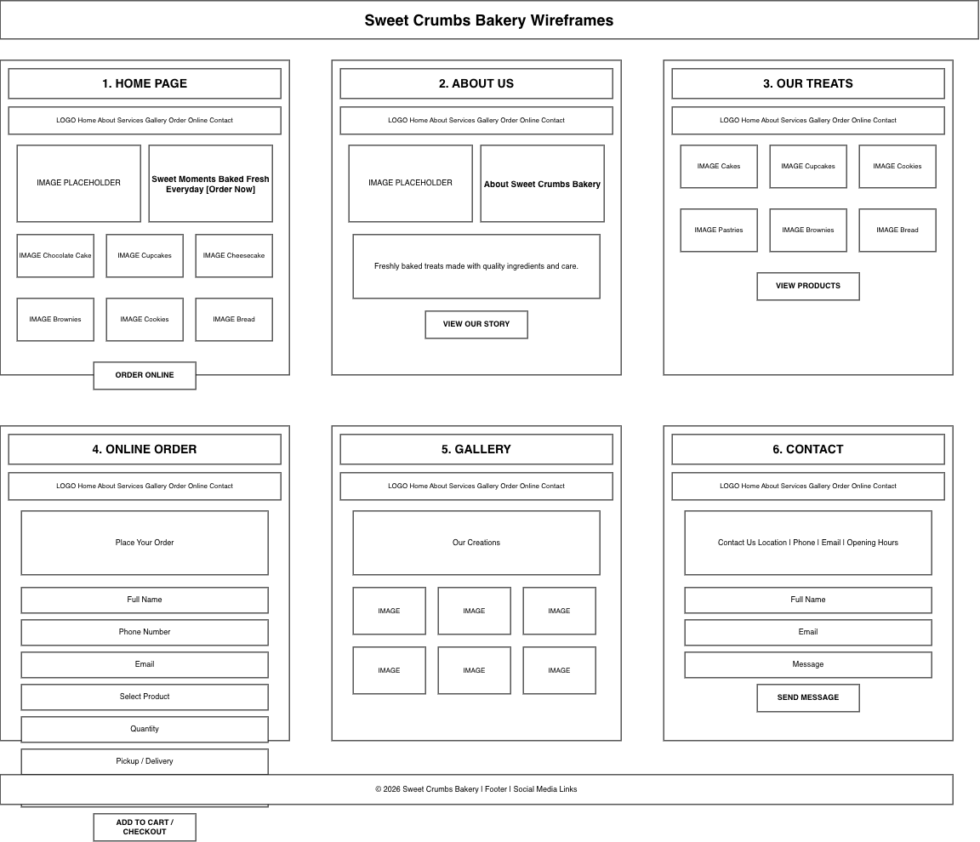

6. Technical Requirements
The website will be developed using HTML5, CSS3 and JavaScript. A domain name such as www.sweetcrumbsbakery.co.za and reliable web hosting will be required. The website will be tested on Google Chrome, Microsoft Edge and Mozilla Firefox to ensure compatibility across modern web browsers.

7. Timeline and Milestones

Week | Activity
1 | Research and planning
2 | Website design and wireframes
3 | Website development
4 | Testing, revisions and final launch

8. Budget
Item | Estimated Cost (ZAR)
Domain registration | R250
Web hosting (annual) | R1,200
Website development | R2,000
Testing and maintenance | R550
Total= | R4,000

References
Duckett, J. (2021) HTML and CSS: Design and Build Websites. Indianapolis: John Wiley & Sons.
Krug, S. (2014) Don’t Make Me Think, Revisited: A Common Sense Approach to Web Usability. 3rd edn. Berkeley, CA: New Riders.
Laudon, K.C. and Traver, C.G. (2023) E-commerce 2023–2024: Business, Technology, Society. 18th edn. Harlow: Pearson.

Table of Contents: Elegance Hair & Beauty Salon Website

Contents | Page
1. Organization Overview | 9
2.Website Goals and Objectives | 9
3. Current Websites Analysis | 9
4.Proposed Website Features and Functionality | 10
5. Design and User Experience | 10
5.1 Low Fidelity Wireframes | 11
6. Technical Requirements | 12
7. Timeline and Milestones | 12
8. Budget | 12
10 REFERENCES | 12

Proposal 2: Elegance Hair & Beauty Salon Website
1. Organisation Overview
Organisation Name:
Elegance Hair & Beauty Salon

Background
Elegance Hair & Beauty Salon is a fictional beauty salon located in Johannesburg, South Africa. The salon was established in 2021 to provide professional hair, beauty and wellness services to clients in a comfortable and welcoming environment. Its services include hair styling, braiding, hair treatments, manicures, pedicures, makeup application and skincare treatments. The salon currently relies on walk-in customers, telephone bookings and social media platforms to promote its services. However, without a dedicated website, clients cannot easily view services, prices or book appointments online.

Mission
To deliver high-quality hair and beauty services that enhance clients’ confidence while providing exceptional customer care in a professional environment.

Vision
To become one of Johannesburg’s leading beauty salons by embracing digital technology, offering convenient online services and building long-lasting relationships with clients.

Target Audience
The website will target:
- Women seeking hair and beauty services.
- Men requiring haircuts and grooming services.
- Teenagers and young adults interested in modern hairstyles.
- Brides and clients booking special occasion beauty packages.
- Working professionals looking for convenient appointment bookings.

2. Website Goals and Objectives
The primary goal of the website is to establish a professional online presence and make it easier for clients to access information and book appointments. The website will showcase available services, prices, promotions and business information while improving communication with clients. Success will be measured through increased appointment enquiries, website traffic and customer engagement (Laudon and Traver, 2023).

3. Current Website Analysis
Elegance Hair & Beauty Salon currently does not have an official website. Clients mainly contact the salon through WhatsApp, Instagram, Facebook and telephone calls. While these platforms support communication, they do not provide a structured appointment booking system or a complete list of services and prices. A dedicated website would improve accessibility, strengthen the salon’s professional image and make booking appointments more convenient (Krug, 2014).

4. Proposed Website Features and Functionality
The website will include the following pages:
- Home
- About Us
- Services
- Gallery
- Book an Appointment
- Contact Us
Clients will be able to browse services, view prices, complete an online appointment request form, access contact information and follow the salon’s social media pages. The website will feature responsive design, clear navigation and attractive images to improve the user experience (Duckett, 2021).

5. Design and User Experience
The website will use elegant colours such as black, gold and white to create a modern and luxurious appearance. High-quality images, clear headings and simple navigation will ensure that clients can quickly find the information they need. The responsive design will provide a consistent experience across desktop computers, tablets and smartphones.

5.1

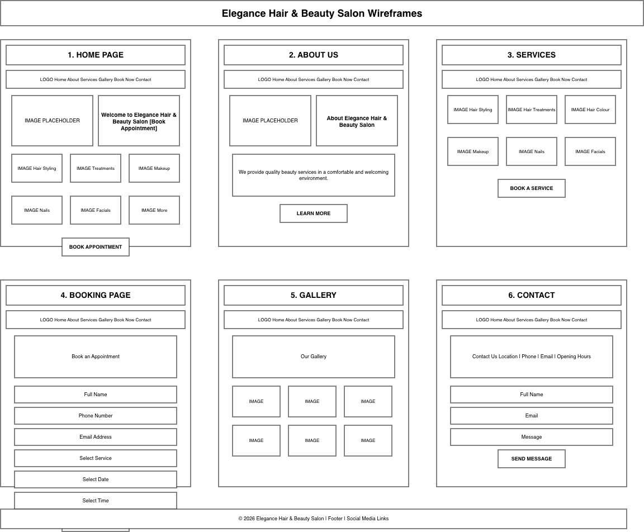

6. Technical Requirements
The website will be developed using HTML5, CSS3 and JavaScript. It will require a registered domain name, reliable web hosting and testing on modern web browsers to ensure compatibility and performance.

7. Timeline and Milestones

Week | Activity
1 | Research and planning
2 | Website design
3 | Website development
4 | Testing and launch

8. Budget

Item | Estimated Cost
Domain registration | R250
Web hosting | R1,200
Web development | R2,000
Testing and maintenance | R550
Total= | R4,000

References (IIE Harvard Anglia)
Duckett, J. (2021) HTML and CSS: Design and Build Websites. Indianapolis: John Wiley & Sons.
Krug, S. (2014) Don’t Make Me Think, Revisited: A Common Sense Approach to Web Usability. 3rd edn. Berkeley, CA: New Riders.
Laudon, K.C. and Traver, C.G. (2023) E-commerce 2023–2024: Business, Technology, Society. 18th edn. Harlow: Pearson.

